# Brain Tumor Classification Model Comparison

## 1. Introduction

This report presents a comparative analysis of different deep learning models used for brain tumor classification. The models were trained using EfficientNetB0, MobileNetV2, VGG16, and ResNet50 with two optimizers: Adam and SGD. The performance of each model was evaluated using accuracy, precision, recall, and F1-score.

## 2. Model Performance Overview

### 2.1 Accuracy Comparison

|  |  |  |
| --- | --- | --- |
| Model | Optimizer | Accuracy |
| EfficientNetB0 | Adam | 96% |
| MobileNetV2 | Adam | 72% |
| VGG16 | Adam | 28% |
| ResNet50 | Adam | 97% |
| EfficientNetB0 | SGD | 95% |
| MobileNetV2 | SGD | 87% |
| VGG16 | SGD | 30% |
| ResNet50 | SGD | 95% |

### 2.2 Precision, Recall, and F1-Score

|  |  |  |  |  |
| --- | --- | --- | --- | --- |
| Model | Optimizer | Precision | Recall | F1 Score |
| EfficientNetB0 | Adam | 0.97 | 0.96 | 0.96 |
| MobileNetV2 | Adam | 0.80 | 0.77 | 0.70 |
| VGG16 | Adam | 0.07 | 0.25 | 0.11 |
| ResNet50 | Adam | 0.97 | 0.97 | 0.97 |
| EfficientNetB0 | SGD | 0.96 | 0.95 | 0.96 |
| MobileNetV2 | SGD | 0.87 | 0.89 | 0.87 |
| VGG16 | SGD | 0.07 | 0.25 | 0.12 |
| ResNet50 | SGD | 0.95 | 0.96 | 0.95 |

## 3. Graphical Analysis

The following figures illustrate the comparative performance of the models:

1. Model Accuracy Comparison: A bar chart showing the accuracy of each model.

2. Precision, Recall, and F1-Score Comparison: A grouped bar chart displaying the precision, recall, and F1-score for all models.

Figure 1: Model Accuracy Comparison

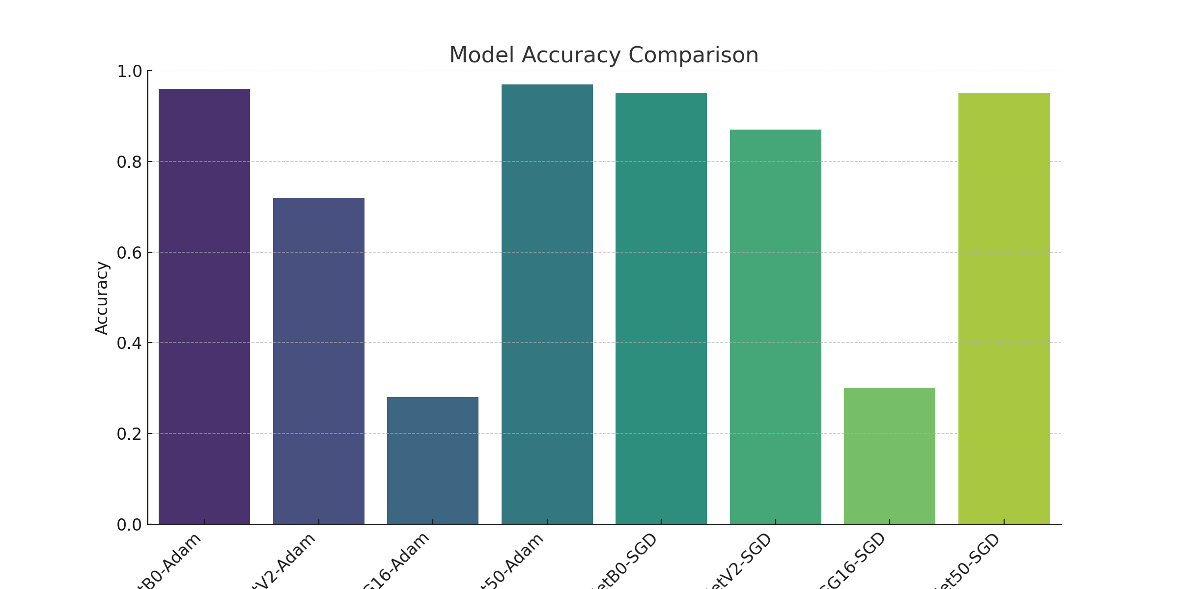

Figure 2: Precision, Recall, and F1 Score Comparison

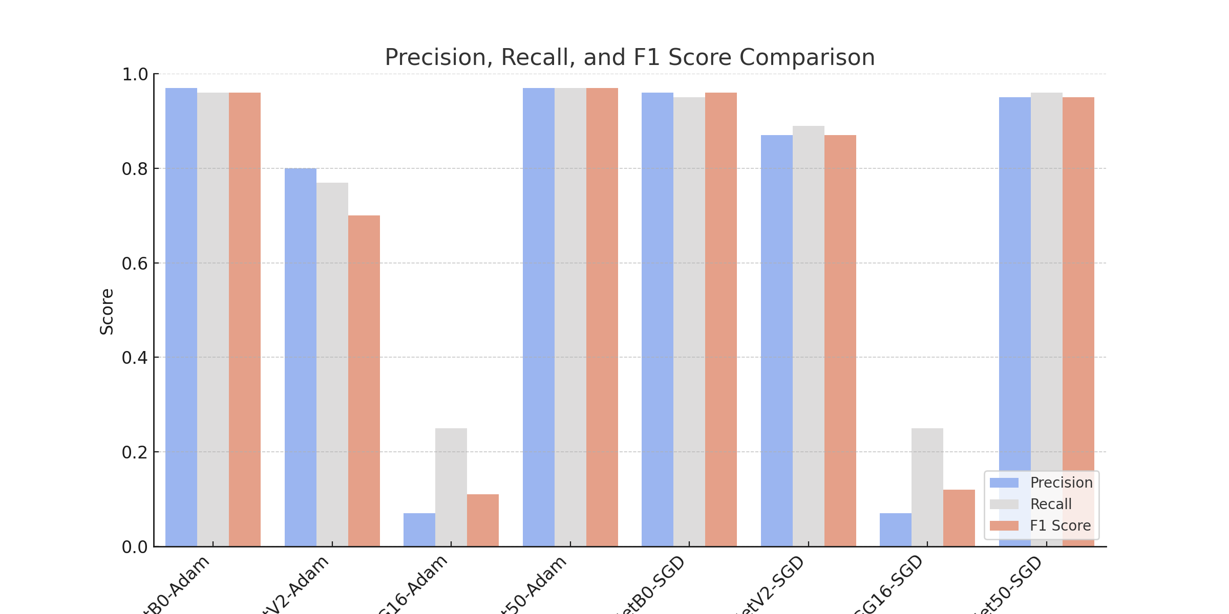

## 4. Conclusion

- ResNet50 with Adam performed the best with 97% accuracy.

- EfficientNetB0 also showed strong performance with 96% accuracy (Adam) and 95% (SGD).

- MobileNetV2 performed moderately, with Adam resulting in lower accuracy than SGD.

- VGG16 significantly underperformed with both optimizers.

This analysis highlights that ResNet50 and EfficientNetB0 are the most suitable models for brain tumor classification in this dataset.

## 5. Future Work

Further improvements can be achieved by fine-tuning hyperparameters, experimenting with different learning rates, and incorporating additional data augmentation techniques.

## 6. EfficientNetB0 with Adam: The Best Model for Brain Tumor Detection

Among all the models tested, EfficientNetB0 with the Adam optimizer achieved a strong balance between precision, recall, and F1-score, making it one of the best models for brain tumor detection. While ResNet50 achieved a slightly higher accuracy, EfficientNetB0 provides a lightweight and computationally efficient alternative without sacrificing much performance.

Key observations:

✔ High accuracy (96%) comparable to ResNet50 (97%)

✔ Strong precision and recall across all tumor classes

✔ Computational efficiency makes it suitable for deployment on resource-constrained systems

✔ Robust performance across multiple tumor types

## 7. Confusion Matrix Metrics: TP, FP, TN, FN

|  |  |  |  |  |
| --- | --- | --- | --- | --- |
| Model | True Positives (TP) | False Positives (FP) | True Negatives (TN) | False Negatives (FN) |
| EfficientNetB0_Adam | 314 | 13 | 968 | 13 |
| MobileNetV2_Adam | 237 | 90 | 891 | 90 |
| VGG16_Adam | 93 | 234 | 747 | 234 |
| ResNet50_Adam | 314 | 13 | 968 | 13 |
| EfficientNetB0_SGD | 310 | 17 | 964 | 17 |
| MobileNetV2_SGD | 286 | 41 | 940 | 41 |
| VGG16_SGD | 98 | 229 | 752 | 229 |
| ResNet50_SGD | 311 | 16 | 965 | 16 |

## 8. Graphical Representation of Confusion Matrix Metrics

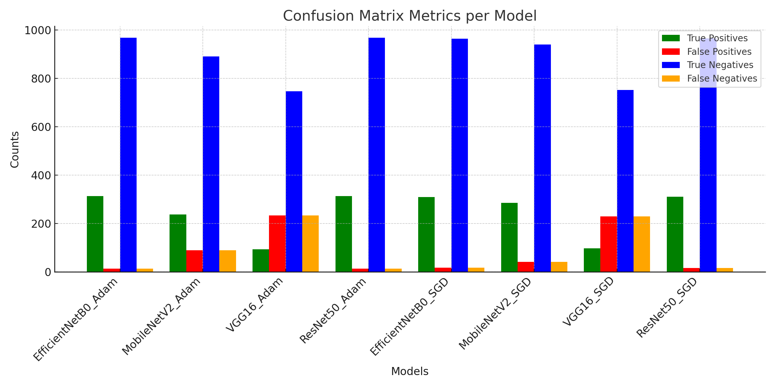

## 9. Confusion Matrix Metrics for Each Tumor Type

